Grazioso Salvare Search and Rescue Dashboard
Project Overview: The Grazioso Salvare Dashboard is a full stack web application designed to help identify and categorize shelter dogs that are strong candidates for specialized rescue training. The dashboard allows users to filter, visualize via the pie chart and map, and to explore data form multiple animal shelters in the Austin, Texas area.

Required functionality
This dashboard allows the user to:
- View an unfiltered table of all animal records from the Austin Animal Center data set.
- Apply interactive filters by rescue type (Water Rescue, Wilderness Rescue, Disaster and Tracking) using radio buttons.
- Dynamically update a data table, a breed distribution pie chart, and a geolocation map in response to filter changes.
- Select any row to update the map with the animal’s location.
- See the Grazioso Salvare logo and developer name for branding and accountability.

Proof of Functionality
Below are screenshots showing the dashboard in action with all required filters and widgets:
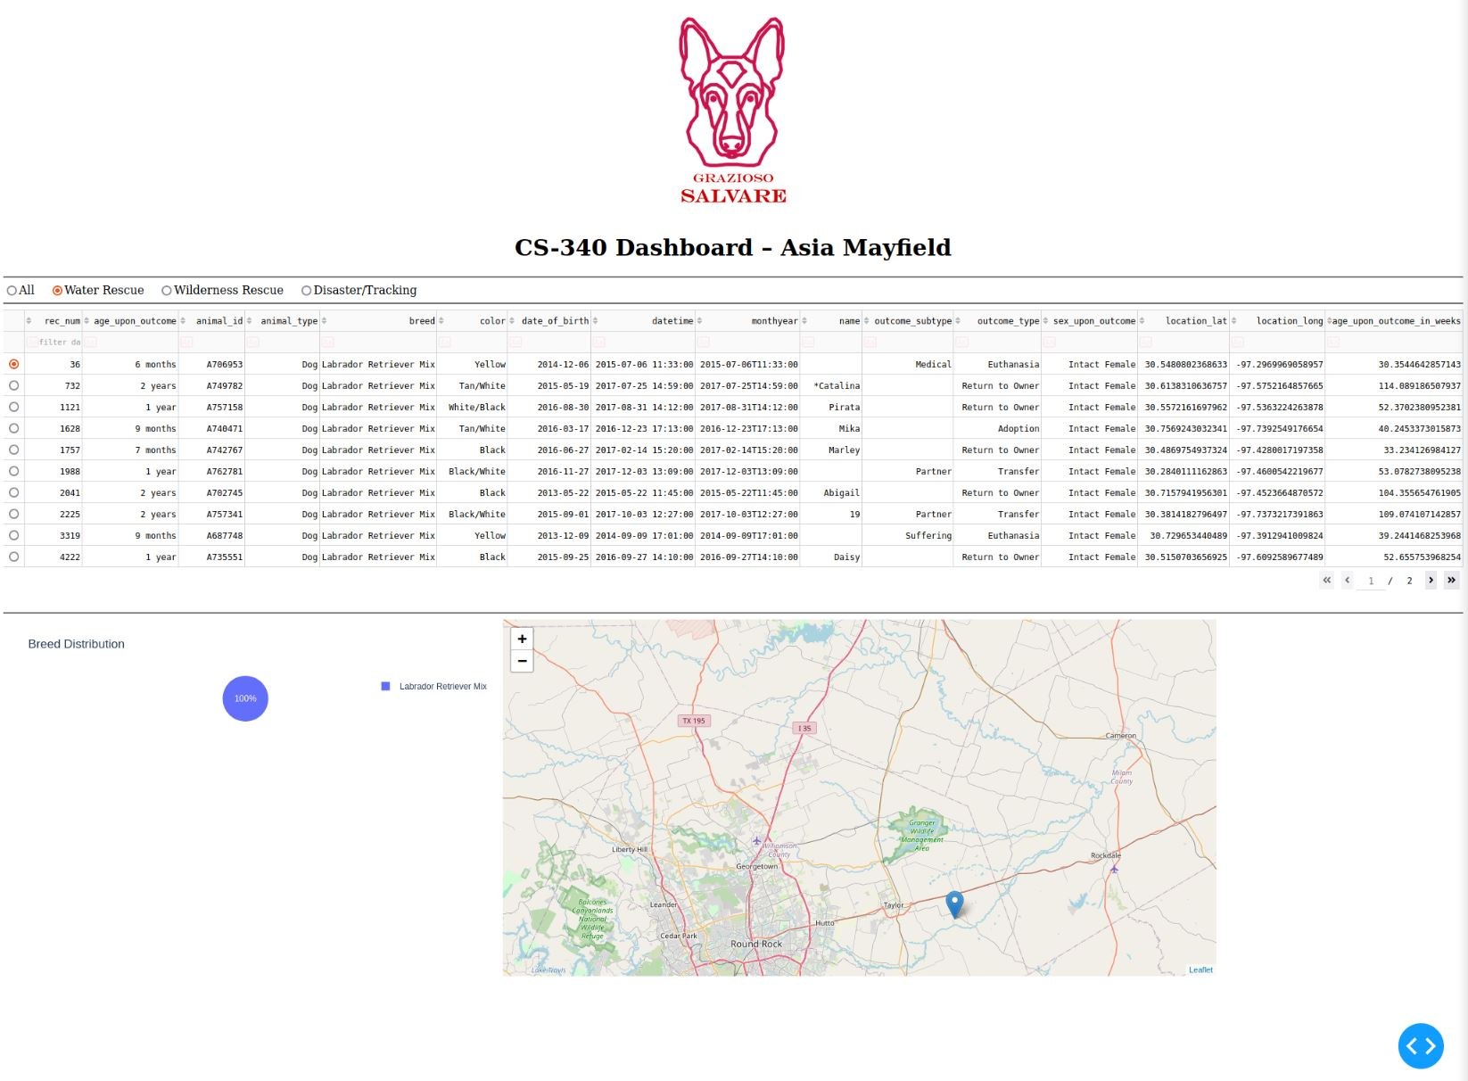Water Rescue Filter
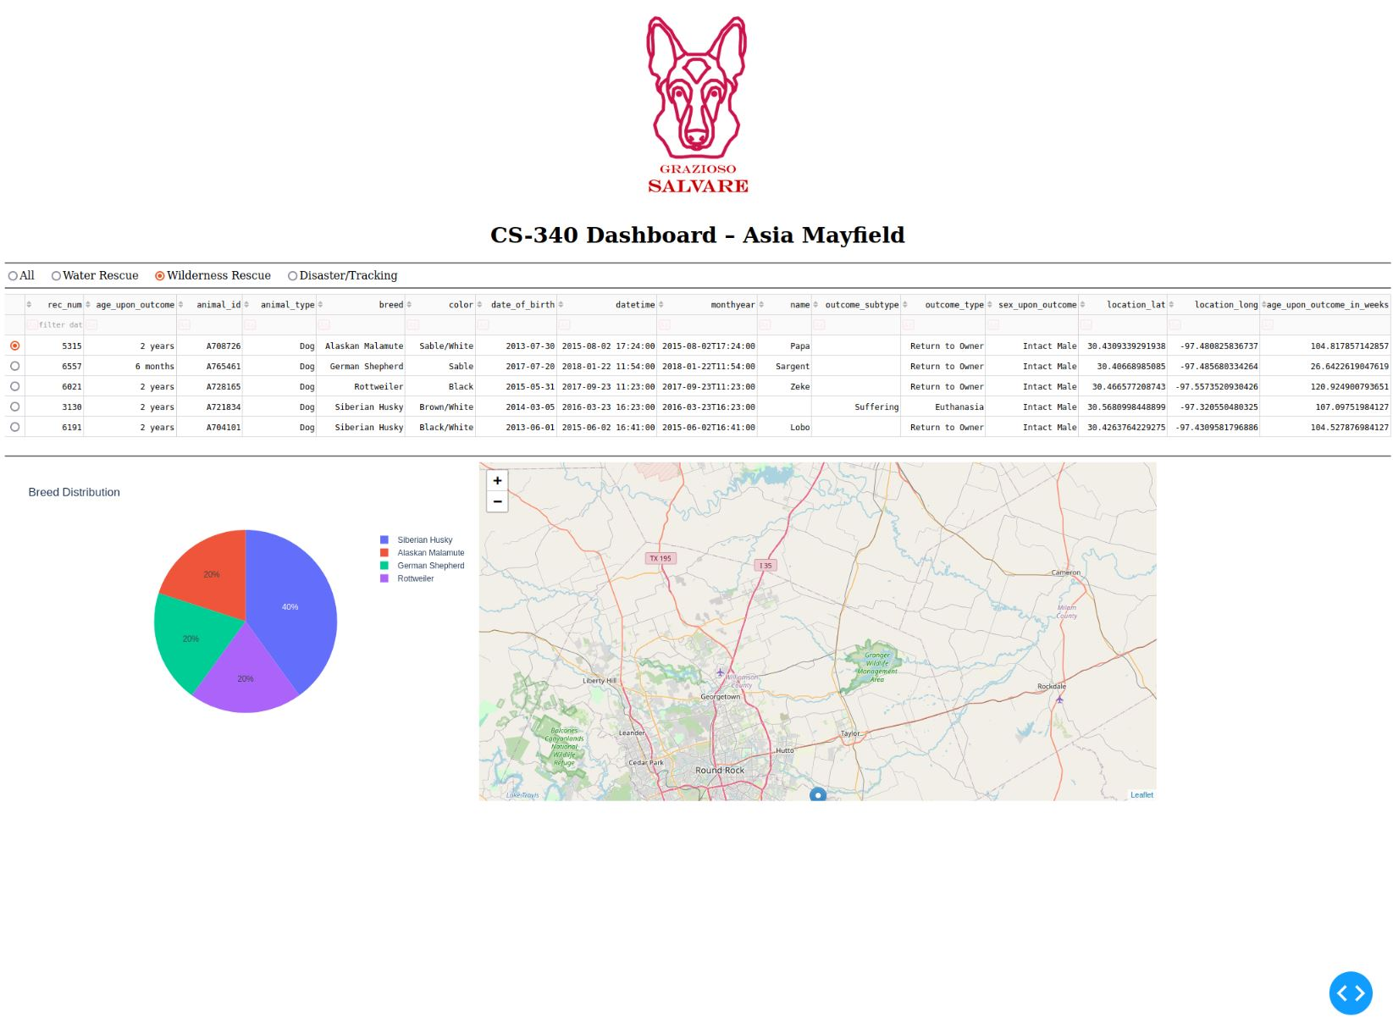
Wilderness Rescue Filter
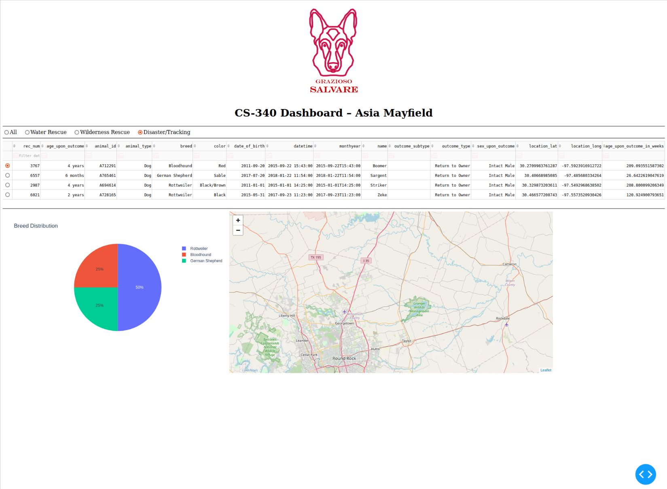Disaster And Tracking

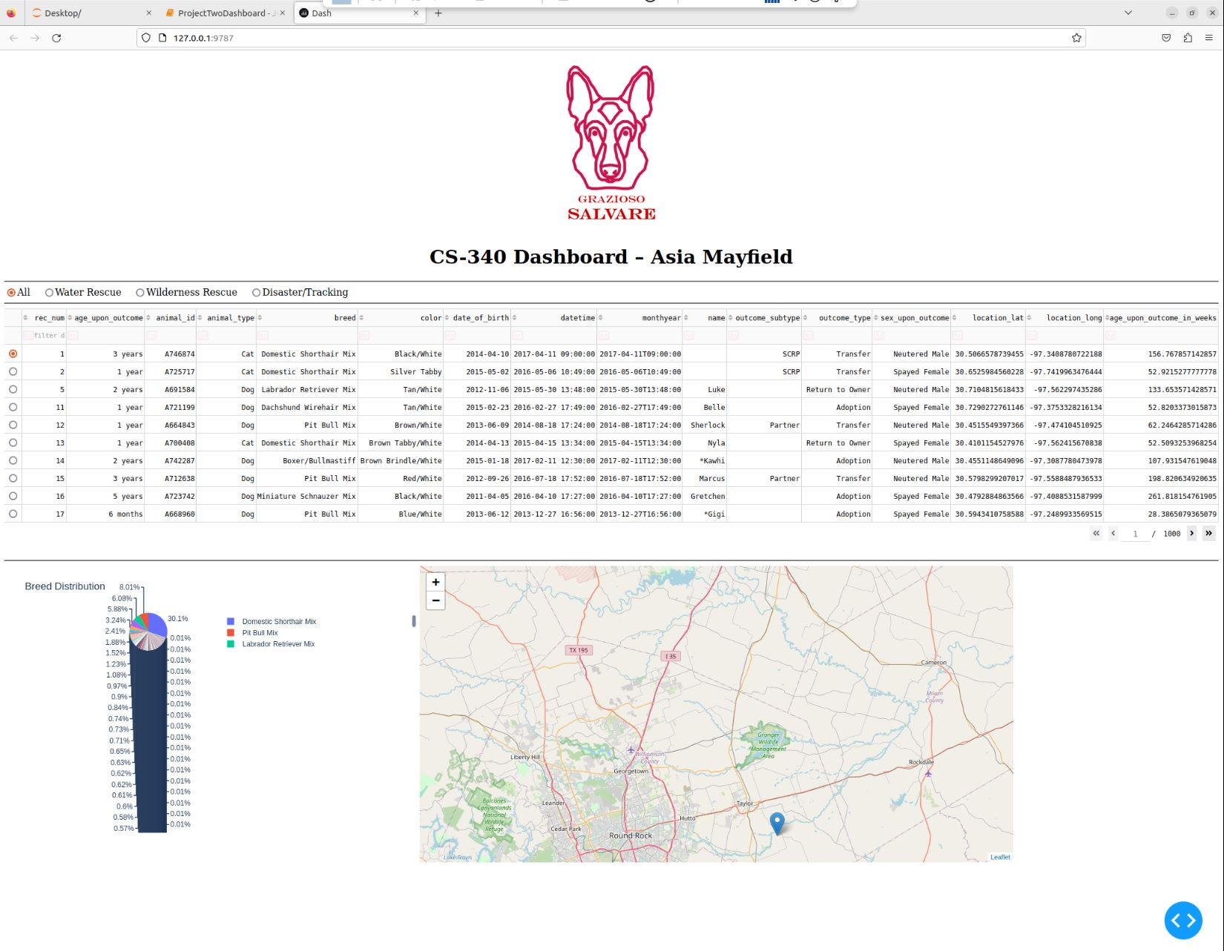
Dashboard reset

Tools Used
- MongoDB: Used as the backend NoSQL database for document storage. Chosen for its native support with Python via PyMongo, its easy integration with JSON style data, and its ability to handle unstructured and structured data from the shelter outcomes spreadsheet.
- Python: The primary programming language for all data handling, CRUD operations, and dashboard logic.
- Dash (by Plotly): A Python web application framework used for building the dashboard interface. It allows for rapid development of interactive web apps using familiar Python code, and integrates seamlessly with Pandas and Plotly visualizations.
- Dash Leaflet: Provides geolocation mapping for selected animals, allowing users to visualize animal locations easily.
- Pandas: Used for data manipulation and conversion between MongoDB records and dashboard components.
- Plotly Express: Used for generating pie charts and other visualizations.
- JupyterDash and Jupyter Notebook: For development and testing in an interactive notebook environment.
- Base64: For embedding the Grazioso Salvare logo directly in the dashboard.

Why MongoDB?
MongoDB was selected for its:
- Flexible, schema less data model; ideal for animal shelter data with varied fields.
- Efficient querying and filtering via JSON like syntax.
- Strong support for Python through the PyMongo library, allowing smooth database operations and integration with dashboard logic.
- Ability to handle large, evolving datasets without strict schemas.

- Be sure to explain the Dash framework that provides the view and controller structure for the web application.
Dash Framework
Dash provides:
- An intuitive way to build interactive dashboards directly in Python.
- View: Dash components (dash_table, dcc.Graph, dcc.RadioItems, etc.) render the data and controls seen by the user.
- Controller: Dash callbacks connect user actions (like clicking a radio button or selecting a row) to database queries and visualization updates, ensuring the app is responsive and dynamic.
- Integrates with Pandas DataFrames and Plotly visualizations for data exploration.

Resources and References
Dash Core Components Documentation
Dash DataTable User Guide
Dash Leaflet Documentation
Plotly Express Pie Charts
MongoDB Documentation
Pandas Documentation
Make a README Guide
PEP 8 Python Style Guide

Project Steps
- Reviewed the dashboard specifications and rescue breed tables provided by the UI/UX developer.
- Created a MongoDB database and loaded the Austin Animal Center Outcomes data.
- Developed a Python CRUD module (animalShelter.py) to support database interactions.
- Built the dashboard in a Jupyter Notebook using Dash and the CRUD module.
- Added filtering controls and widgets (radio buttons, interactive DataTable, pie chart, map).
- Tested all functionality with real data and captured screenshots.
- Packaged and documented the code, preparing for handoff to the client and future developers.

Challenges encoutered and how they were overcome
Data formatting:
Handling MongoDB’s _id field and converting data for use in Dash DataTable.
Solution: Dropped the _id column and ensured all data were serializable.
Dynamic filtering logic:
Making sure filters matched the requirements and only returned valid rescue candidates.
Solution: Carefully matched queries to the rescue breed and age specs from the project documents.
Callback synchronization:
Ensuring that the map and chart update in real time with user selections.
Solution: Used Dash callbacks to “listen” for filter and table changes and update all widgets accordingly.
User Experience:
Making the dashboard visually clean and self-explanatory for client use.
Solution: Followed UI/UX sample, added branding/logo, and selected sensible defaults for filtering and selection.

Contact
Asia Mayfield

